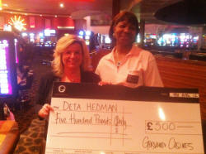
Ladies Winner Deta Hedman with Joanne Hindle (Grosvenor General Manager)

Mens Winner Ronnie Baxter with Joanne Hindle (Grosvenor General Manager) and Tommy Thompson (Lancashire Chairman)

